**VISVESVARAYA TECHNOLOGICAL UNIVERSITY**



MINI PROJECT REPORT ON

**“ANTI BAG SNATCHING ALARM”**

SUBMITTED BY:

**GOVIND RAJ C S (1NH18EC040)**

Under the guidance of

**Dr. Nisha K.C.R**

Professor, Dept. of ECE, NHCE, Bengaluru.

# C:\Documents and Settings\Students\Local Settings\Temporary Internet Files\Content.Word\download (1).jpg

# NEW HORIZON COLLEGE OF ENGINEERING

(ISO-9001:2000 certified, Accredited by NAAC ‘A’, Autonomous college permanently affiliated to VTU)Outer Ring Road, Panathur Post, Near Marathalli, Bengaluru-560103

## NEW HORIZON COLLEGE OF ENGINEERING

## DEPARTMENT OF ELECTRONICS AND COMMUNICATION ENGINEERING



**CERTIFICATE**

Certified that the mini project work entitled “**Anti Bag Snatching Alarm**” carried out by **G Sai Sandeep(1NH18EC033), P Chandra Mohan(1NH18EC024), ANVS Manideep  
(1NH18EC012), CS Govind raj(1NH18EC040),** bonafide students of Electronics and Communication Department, New Horizon College of Engineering, Bangalore.

The mini project report has been approved as it satisfies the academic requirements in respect of mini project work prescribed for the said degree.

Project Guide HOD ECE

------------------------- -------------------------

**External Viva**

Name of Examiner Signature with Date

1.

2.

**ACKNOWLEDGEMENT**

The satisfaction that accompany the successful completion of any task would be, but impossible without the mention of the people who made it possible, whose constant guidance and encouragement helped us succeed.

We thank **Dr. Mohan Manghnani**, Chairman of **New Horizon Educational Institution**, for providing necessary infrastructure and creating good environment.

We also record here the constant encouragement and facilities extended to us by **Dr. Manjunatha**, Principal, NHCE and **Dr. Sanjeev Sharma**, Head of the Department of Electronics and Communication Engineering. We extend sincere gratitude to them.

We sincerely acknowledge the encouragement, timely help and guidance to us by our beloved guide **Dr. Nisha K.C.R** to complete the project within stipulated time successfully.

Finally, a note of thanks to the teaching and non-teaching staff of electronics and communication department for their co-operation extended to us, who helped us directly or indirectly in this successful completion of mini project.

**GOVINDRAJ C S (1NH18EC040)**

**TABLE OF CONTENTS**

ABSTRACT 6

**CHAPTER 1**

INTRODUCTION 7

**CHAPTER 2**

LITERATURE SURVEY 8

**CHAPTER 3**

PROPOSED METHODOLOGY 11

**CHAPTER 4**

PROJECT DESCRIPTION 12

4.1 HARDWARE DESCRIPTION 14

**CHAPTER 5**

RESULT AND DISCUSSION 30

**CHAPTER 6**

CONCLUSION AND FUTURE SCOPE 32

REFERENCES 33

APPENDIX 34

**LIST OF FIGURES**

|  |  |  |  |
| --- | --- | --- | --- |
| **SL**  **No** | **FIGURE**  **No** | **FIGURE DESCRIPTION** | **Page**  **No** |
| 1 | 4.1 | Circuit diagram | 12 |
| 2 | 4.2 | Pin diagram of IC CA3140 | 14 |
| 3 | 4.3 | Block diagram of IC CA3140 | 14 |
| 4 | 4.4 | Pin diagram of 555 timer IC | 16 |
| 5 | 4.5 | Block diagram of 555 timer IC | 17 |
| 6 | 4.6 | Pin diagram of UM3561 IC | 19 |
| 7 | 4.7 | Block diagram of UM3561 IC | 20 |
| 8 | 4.8 | Pin diagram of transistor (BD139) | 22 |
| 9 | 4.9 | Zener diode | 23 |
| 10 | 4.10 | Resistors | 25 |
| 11 | 4.11 | Variable resistor | 26 |
| 12 | 4.12 | Speaker | 27 |

### LIST OF TABLES

|  |  |  |  |
| --- | --- | --- | --- |
| **SL**  **No** | **Table**  **No** | **TABLE DESCRIPTION** | **Page**  **No** |
| 1 | 1.1 | Components used in the project | 13 |

**ABSTRACT**

The main objective of this project is to design an electronic circuit that will serve to prevent the theft of bag or suitcase. Anti bag theft alarm circuit used in the bag or suitcase to prevent it from theft. It is a simple alarm circuit stored in a bag or suitcase that looks like a powerful alarm, simulating a police horn. This will draw attention to the other people and the thief can be catch hold of easily. Then, when the thief tries to snatch the bag or suitcase the plug gets detected from the circuit and the alarm goes off. The heart of all this project is operational amplifier which is configured as a comparator. 555timer -IC is used as a monostable multivibrator and for the audio section sound generator with built in oscillator is used. Once the sound is amplified, it is powered to the speaker for the output. The anti-theft bag alarm kit uses a circuit and simulates a police horn if someone tries to pull it off. Therefore, while travelling this kit allows the person to carry money or valuables without any fear. The alarm can only be disabled by the authorized person. The main components it consists are 555 timer -IC, an operational amplifier, an in-built oscillator, resistors, transistor (BD139), diode, ceramic and electrolytic capacitors, variable resistor. This project is useful especially in case of women while carrying bag or suitcase when travelling.

**CHAPTER 01**

**INTRODUCTION**

Our project is usually used while traveling long distances carrying a bag or suitcase in hand. It can be designed on a PCB and breadboard as well. It consists of many components like 555timer-IC, operational amplifier which acts as a comparator, in built oscillator, transistor, resistors, speaker or buzzer, diode, variable resistor, 9V battery, battery holder. The operational amplifier IC is the heart of the whole circuit which acts a comparator. In recent days, the theft rate is very high in the world. They are even worse in the developing countries. Therefore, protecting portfolios with the intelligent, reliable, efficient and economical system is very important. The existence of technologies for handbags and safety bags have a number of limitations, including high false alarm rate, easy deactivation and high cost. In this project, an anti-theft handbag the security system will be designed using a UM3561 oscillator that will cause a alarm to activate. The main purpose of this project is to prevent snatching of bags and suitcases and to catch hold of the person. This project makes the life of a person easier who is travelling at very long distances without any fear. It is reliable, efficient, and handy. Once the circuit is kept inside the bag connect a jack to it. Then tie it to your bag or suitcase. If anyone snatches, we can get to know that someone is snatching the valuables present in the bag or suitcase. This circuit is most commonly used while travelling long distances and carrying any valuables in it. It produces a very large sound when the intruders try to snatch the bag or suitcase.

**CHAPTER 02**

**LITERATURE SURVEY**

* **Electronicsforu.com (**Published in February 2004)

Now-a-days, there are many thefts going on around us especially in case of women. This anti-bag snatching alarm provides a simple solution for this. When someone tries to snatch the bag the jack which is connected to the circuit detaches from it and it produces an alarm signaling that there is someone who is snatching the bag. This alerts the person who is carrying the bag or suitcase. So, to prevent this theft we use this circuit called anti-bag snatching alarm.

* **Slideshare.net (**by Soumya Tiwari and published on Dec 4 2017)

Today, people are still terrified of thieves. Day by day, it is growing in society. Above all, women are not safe with the bag outside. For this reason, to eliminate American investor Richard w. Dixon invented the handbag theft alarm in 1971. This was the first use of the theft alarm. It was based on the theory that sudden pull or shaking force exerted by the handle of the bag will cause the alarm to be triggered. In order, to prevent this we can use this circuit anti-bag snatching alarm.

* **Electronicsproject.org**

Here is a very simple project, as well as very useful anti-bag alarm to snatch the project, used in the bag or suitcase in order to prevent theft. The sound produced by the alarm anti-bag snatching is like the police horn to attract people's attention when someone tries to snatch their handbag or suitcase. This circuit provides safety in order to prevent loss of the valuables in the bag or suitcase. This provides safety especially in case of women who travel frequently with their bag or suitcase.

* **Academia.edu** (Published in February 2004 by Anurag dandge)

In recent days, the rate of theft is very high in the world and the situation are even worse in developing countries. As a result, the protection of intelligent, reliable, efficient and economical system is very important. The technologies for bag and bag safety have a number of limitations, theft alarm rate, easy deactivation and high cost. In this project, an anti-bag snatching security system will be designed using the vibration sensor system that will alarm to trigger and alert the people who are carrying a bag or suitcase. This security is very much needed in this developing country to protect our own citizens from thefts.

* **Electronicshub.org**

This is a simple alarm circuit to thwart the snatching of your valuables during the trip. The circuit placed in your bag or suitcase sounds a loud alarm, simulating a police horn, if someone tries to snatch your bag or suitcase. This will attract the attention of other passengers and the thief can be caught immediately. In standby mode, the circuit is blocked by a socket (a mono socket with short cables connected to the unit's single-jack socket). When the thief tries to snatch the bag, the socket separates from the unit socket and triggers the alarm.

* **Scribd.com**

This project acts as a safety measure to all those who travel along with their bags and suitcases. It sounds like a police horn, when the jack attached to the circuit detaches from it. This makes the person alert who is carrying the bag or suitcase along with them and they can catch hold of the person immediately. So, this acts as a safety kit to all the citizens out there especially to women who travel very often. This can be used as a security alarm whenever it is needed. This circuit is most often used while travelling with money or valuables inside the bag or suitcase.

* **Tronicchoice.wixsite.com**

The alarm bag kit uses a circuit that is blocked by a standby and take device. The kit can be stored in a bag or suitcase and simulates a police horn if someone tries to pull it off. Therefore, during the trip, this kit entitles the person to carry money or valuables without fear. The alarm can only be deactivated by the authorized person.

* **Freecircuits.wordpress.com**

It's a simple alarm circuit to thwart the bursting of your valuables while you're traveling. The circuit stored in your bag or suitcase sounds a loud alarm, simulating a police horn, if someone tries to snatch your bag or suitcase. This will attract the attention of other passengers and the thief can be caught red handed. In standby mode, the circuit is blocked by a socket. When the thief tries to snatch the bag, the socket separates from the unit socket to trigger the alarm.

**CHAPTER 3**

**PROPOSED METHODOLOGY**

* Initially, we analyzed the circuit diagram in order to proceed forward.
* Then, we bought the components and placed all the components on the bread board.
* We placed the 1st IC and surrounding components on the bread board then we have checked the output waveforms on the CRO by applying certain voltage.
* Then, we placed the 2nd IC i.e. 555Timer and checked the output waveforms on the CRO at pin 3 of the IC.
* Then, we connected the 3rd IC i.e. the oscillator IC and connected the transistor to check whether the signal received from the IC is being amplified or not.
* Then, we have connected all the other components like resistors, capacitors, diode, etc.
* Then, we connected the transistor to the speaker to produce an alarm.
* Then, we have connected a switch in order to switch off the alarm sound.
* Then, we placed the circuit in the bag or suitcase to check, when the monoplug is detached whether it is producing an alarm or not.

**CHAPTER 04**

**PROJECT DESCRIPTION**

Our project is mainly based on the CA3140 IC which acts a comparator in the circuit. There are mainly 3 pins which are connected. The remaining pins are connected to Vcc and Ground. It has 2 pins which are named as inverting ang non-inverting terminals. The output is connected to pin 6. Based on the input given at the inverting and non-inverting terminals it produces the output. The output is fed to the next IC i.e. 555-Timer IC which is in monostable state. The same output comes at the pin no 3 of the 555-Timer IC. This output is given to the next IC i.e. UM3561 which acts as a oscillator in the circuit. The output of this IC is given to the transistor. The transistor amplifies the output signal and is given to the speaker to produce an alarm when connected to the supply. So, when the intruders try to snatch the bag the monoplug gets detached from the circuit and it produces an alarm. The components used are 3 IC’s- CA3140, NE555timer, UM3561, speaker, transistor (BD139), Zener diode, resistors, monoplug, monojack socket, ceramic and electrolytic capacitors, variable resistor.

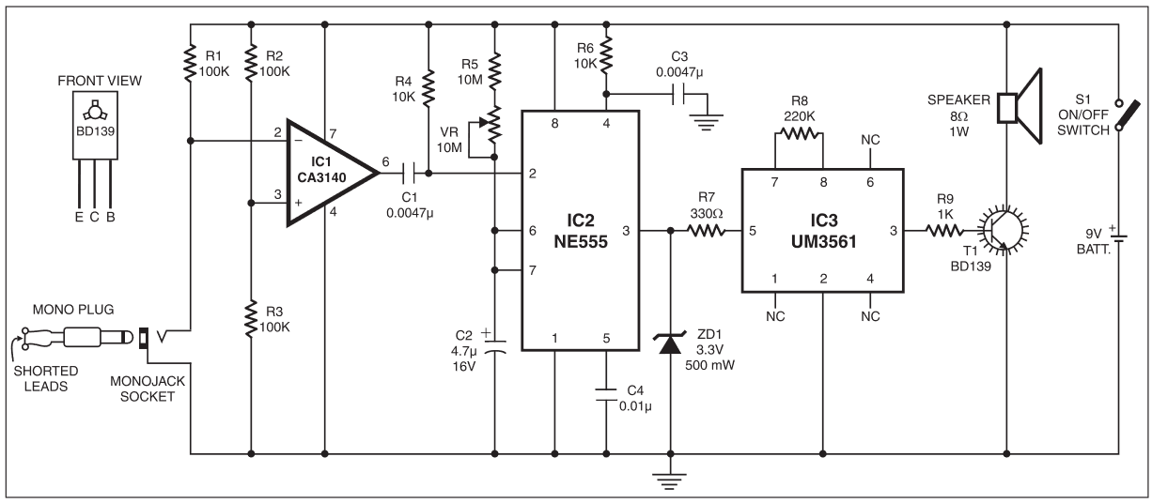

**Fig: 4.1.** Circuit diagram

COMPONENTS USED: -

**Table 1.1.** Components used in the project

|  |  |  |
| --- | --- | --- |
| COMPONENT | VALUE (OR) SPECIFICATION | REMARKS |
| IC CA3140 | High input impedance | Operational amplifier |
| IC NE555-TIMER | Supply voltage - +16V | Timer |
| IC UM3561 | Typically, +3 operating voltage | In-built oscillator |
| TRANSISTOR | BD139 | Amplifies the circuit |
| CAPACITOR | 4.7uF | Electrolytic |
| CAPACITOR | 0.0047uF, 0.01uF | ceramic |
| RESISTORS | 330ohms,220ohms,100Kohms  10Mohms,10Kohms, 1Kohm | Reduces the current flow |
| SPEAKER | 8ohms, 1W | Generates an alarm |
| ZENER DIODE | 3.3V | Used as a voltage regulator |

**IC CA3140**

PINOUT DIAGRAM

**[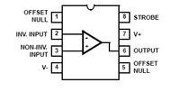](https://www.electroschematics.com/wp-content/uploads/2010/07/CA3140-Pins.png?resize=200%2C102)**

**Fig 4.2.** Pin diagram of IC CA3140

Pin1: Offset Null  
Pin2: Inverting input   
Pin3: Non inverting input   
Pin4: Ground- Negative supply  
Pin5: Offset Null  
Pin6: Output  
Pin7: Positive supply  
Pin8: Strobe

BLOCK DIAGRAM:

**[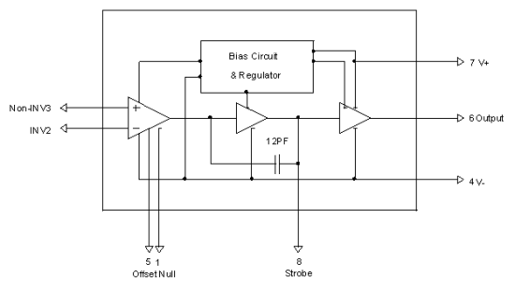](https://www.electroschematics.com/wp-content/uploads/2010/07/CA3140-Block-Diagram.png)**

**Fig 4.3.**  Block diagram of IC CA3140

Operating conditions are:

* Maximum supply voltage - 36V
* Input terminal current - 1mA

WORKING:

CA3140 is the 4.5MHz BiMOS Operational Amplifier with MOSFET inputs and Bipolar output. This Op Amp combines the advantage of PMOS transistors and high voltage bipolar transistors. It acts as a operational amplifier. It has inverting and non-inverting terminals. Here, pin no. two is the inverting terminal and pin no. three is the non- inverting terminal. If the input at the inverting terminal is high and low at the non-inverting terminal then the output is high at pin no. six and vice-versa. The IC is incredibly quick and it has high speed performance. It uses bi polar transistors at the output. These operational amplifiers are internally phase compensated to achieve stable operation in unity gain.

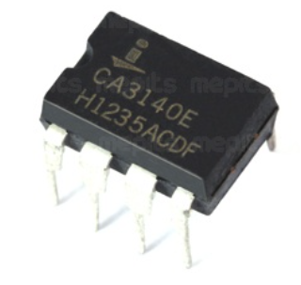

**NE555- TIMER IC**

PINOUT DIAGRAM

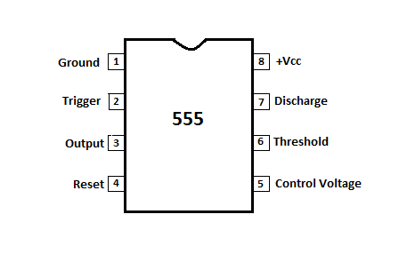

**Fig 4.4.** Pin diagram of NE555 – Timer

Pin 1: Ground

Pin 2: Triggering

Pin 3: Output

Pin 4: Reset

Pin 5: Control

Pin 6: Threshold

Pin 7: Discharge

Pin 8: positive supply voltage

Operating conditions are :

* Supply voltage ranges from +5V to +18V
* Load current of 200mA

BLOCK DIAGRAM

[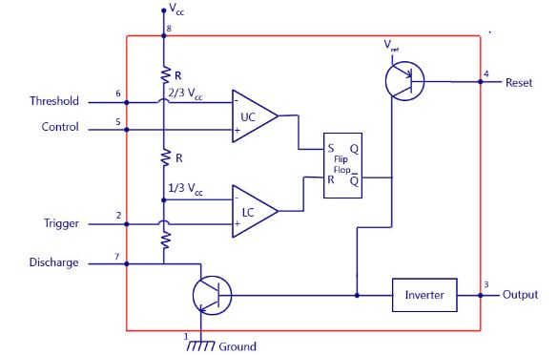](https://electronicsforu.com/wp-contents/uploads/2016/11/555-block-diagram.jpg)

**Fig 4.5.** Block diagram of NE555 - Timer

WORKING: -

555 timer has 3 modes they are:

1. A- stable
2. Mono- stable
3. Bi- stable

A-stable mode:

This means that there will be no stable level in the output. Thus, the exit will swing between high and low. This unstable output character is used as a clock output or square wave for many applications.

Mono-stable mode:

This configuration consists of a stable state and an unstable state. The stable state can be chosen high or low by the user. If the stable output is fixed at high (1), the timer output is high (1). In applying an interruption, the timer output becomes low (0). Since the low state is unstable, it will automatically be high (1) after the interruption passes. The same goes for a stable monostable mode.

Bi- stable mode:

In bistable mode, both the output states are stable. At each interrupt, the output changes from low (0) to high (1) and vice versa, and stays there. For example, if we have a high (1) output, it will go low (0) once it receives an interrupt and stays low (0) till the next interrupt changes the status.

Features of 555timer:

* External components must be selected correctly so that time intervals can be run in several minutes with frequencies greater than several hundred kilohertz.
* The output of a 555 timer can lead to transistor-transistor (TTL) logic due to its high power output.
* The timer service cycle is adjustable.

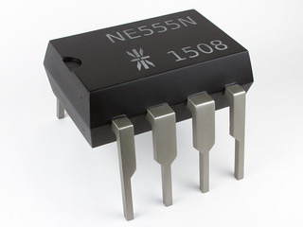

**IC UM3561**

PINOUT DIAGRAM

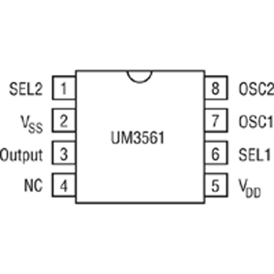

**Fig 4.6.** Pin diagram of IC UM3561

Pin 1: Sound effect Selection

Pin 2: negative power supply

Pin 3: Mono-tone output

Pin 4: Not connected

Pin 5: positive power supply

Pin 6: sound effect selection pin1

Pin 7: external oscillator 1

Pin 8: external oscillator 2

BLOCK DIAGRAM

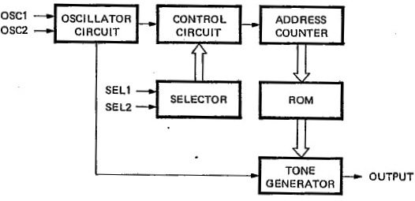

**Fig 4.7.** Block diagram of IC UM3561

FEATURES:

* When we reset, we can get the power
* It has an operating voltage of 3V
* It is very low cost
* It acts like a NPN transistor

WORKING:

It mainly produces four types of sounds they are:

1. Police horn
2. Ambulance horn
3. Fire engine sound
4. Machine gun sound

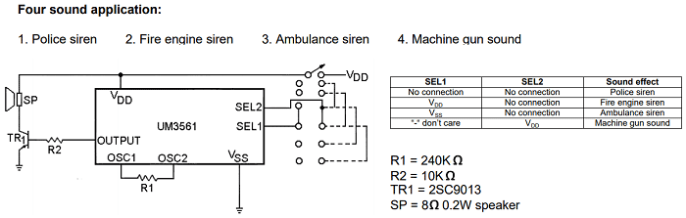

* when SEL1 and SEL2 are not connected we get a police horn.
* When SEL1 is connected to VDD and SEL2 is not connected we get a fire engine horn.
* When SEL1 is connected to VSS and SEL2 is not connected we get a ambulance horn.
* When SEL1 is connected to don’t care and SEL2 is connected to VDD we get a machine gun sound.

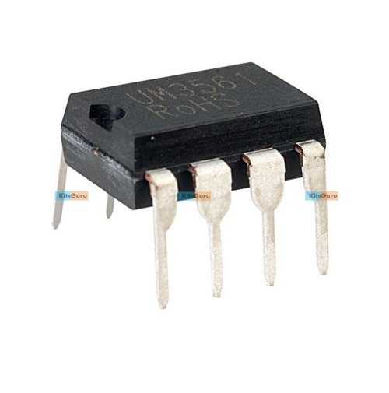

**TRANSISTOR (BD139)**

PINOUT DIAGRAM

[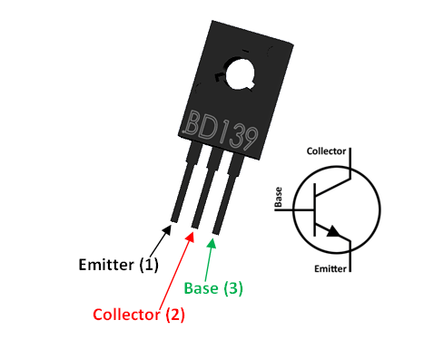](https://components101.com/sites/default/files/component_pin/BD139-Transistor-Pinout.png)

**Fig 4.8.** Pin diagram of transistor (BD139)

Pin 1: current drains out via emitter

Pin 2: current flows via collector

Pin 3: it is used to control the biasing of the transistor

FEATURES:

* It is made up of plastic
* The continuous current of the collector is 1.5A
* The decomposition voltage is 5V

WORKING:

* BD139 is an NPN transistor so the collector and transmitter will be left open (inverted shady) when the base pin stays on the ground and will close (before shaded) when a signal is provided to the base pin.
* BD139 has a gain value of 40 to 160, this value determines the amplification capacity of the transistor.
* The maximum current that the collector can hold is 1.5A, so we cannot connect the charges that consume more than 1.5A using the BD139 transistor.

**ZENER DIODE**

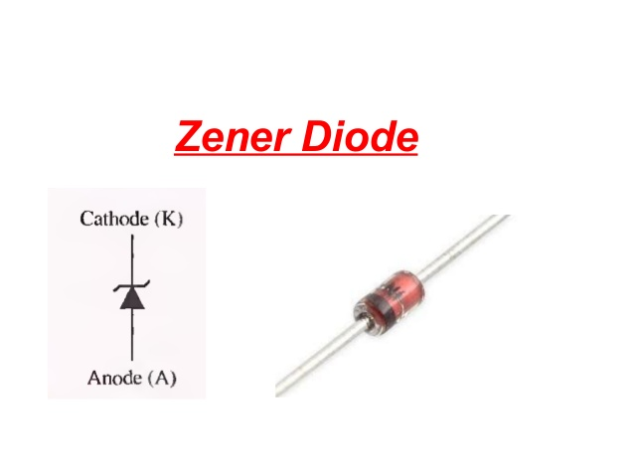

**Fig 4.9.** Zener Diode

Pin 1: cathode(K) (-ve)

Pin 2: anode (A) (+ve)

A Zener diode is a silicon semiconductor device that allows current to flow in forward or reverse direction. The diode consists of a highly doped special p-n junction, designed to operate in the opposite direction when a certain specified voltage is reached.

FEATURES

* It is highly reliable
* Very sharp reverse characteristic
* Low current level
* The voltage is 3.3V
* It consists of two terminals.
* It has cathode and anode

PRINCIPLE

If the reverse bias voltage is lower than the cutoff voltage or if the Zener diode is forward biased, it acts as an ordinary diode. That is to say that in direct polarization, it allows the current and in reverse polarization, it blocks the current.

WORKING

The Zener diode operates in the same way as the normal diode in the forward bias mode and has an ignition voltage of between 0.3 and 0.7V. However, when connected in reverse mode, this is Common in most of the cases. When the reverse voltage increases to the predetermined breaking voltage, a current begins to flow in the diode. The current increases to a maximum, which is determined by the series resistance, after which it stabilizes and remains constant over a wide range of applied voltage.

**RESISTORS**

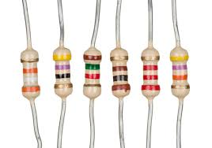 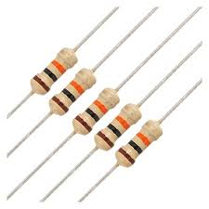

**Fig 4.11.** Resistors

* A resistor is considered to be a two terminal passive element that introduces a certain level of resistance into the electrical circuit.
* The main roles of resistor in an electrical circuit are to reduce the flow of current, divide the voltage level, adjust the signals.
* So, the main use of the resistors is to reduce the flow of current into an electrical device or circuit.
* We can get resistors of different resistance values which can be used in our projects.

**VARAIBLE RESISTOR**

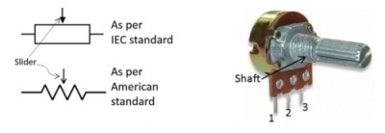

**Fig 4.12.** Variable resistor

* A variable resistor is the one which is used to control the circuit resistance. It is also called as the potentiometer.

* It has three terminals which are to be connected.
* There are 3 terminals called as cermet path, carbon path, wire wound path.
* Carbon path and cermet path are used for high strength applications, whereas the wire wound path is used for low resistance variable resistor.
* It can be used as a potentiometer.
* Potentiometer is used as a most common type of variable resistor.
* It has high working efficiency.

**SPEAKER**

 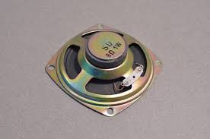

**Fig 4.13.** Speaker

DESCRIPTION

* A loudspeaker is a device which converts electrical audio to sound which can be heard.
* These are the transducers used to convert electromagnetic waves into sound waves.
* The speaker receives the input from the computer or the audio receiver.
* The input supplying to the speaker is analog or digital.
* The speaker has many entities like impedance, power handling, size, frequency response.
* It has two terminals namely red and black.
* Red is connected to the collector pin of the transistor (BD139) and the black is connected to the supply.
* The speaker used here in the circuit is of 8ohms-1W.

**WORKING**

* The circuit is designed around the IC CA3140 operational amplifier, which is configured as a comparator. The non-inverting input(pin3) of IC1 is maintained at half the supply voltage around 4.5V by the variable resistor(potentiometer) comprising resistors R2 and R3 of 100 kilo-ohms each. The inverting input (pin2) of IC1 is kept low by the short plug in the socket. As a result, the voltage at the non-inverting input is greater than that at the inverting input and the output of IC1 is high. The output of pin 6 of IC1 is transmitted to the activation pin 2 of the IC NE555(IC2) through the coupling capacitor C1. IC2 is configured as monostable. Its trigger pin 2 is kept high by the resistor R4. Normally, the output of IC2 remains low and the alarm is disabled.

Resistor R6 and capacitor C3 connected to reset pin 4 of IC2 prevent any false triggering. The resistor R5, the preset VR and the capacitor C2 are timing components. With these values, the output at pin 3 of IC2 is about one minute, which can be increased by increasing the value of capacitor C2 or preset VR. When attempting to snatch, the plug connected to the circuit is disconnected. At this time, the voltage at the inverting input of IC1 exceeds the voltage at the non-inverting input and, subsequently, its output drops. This sends a low pulse to trigger pin 2 of IC2 so that its pin 3 output is high. As a result, the alarm circuit built around the IC UM3561 obtains the supply voltage at pin 5. The IC UM3561 is a complex ROM with an integrated oscillator. Resistor R8 is the oscillator component.

Its output is fed to the base of the one-stage transistor amplifier BD139(T1) via the resistor R9. The alarm tone generated by IC3 is amplified by the transistor T1.A loudspeaker is connected to the collector of the transistor(T1) to trigger the alarm. The alarm can be disabled if the plug is reinserted back into the monojack socket. The resistor r7 limits the current to IC3 and Zener diode ZD1 limits the supply voltage to IC3 to a required level of 3.3V. Resistor R9 limits the current to the base of the transistor. The circuit can easily be constructed on general purpose Printed circuit board or it can also be done on a breadboard. We provide a 9V power supply to the circuit. The speaker must be small so that it will be easy to hold the circuit in hand. By connecting a thin plastic cable to the plug and attaching it by hand or attaching it to another location so that when you pull the bag, the plug will easily separate from the jack and produces a alarm and the burglar can be caught easily.

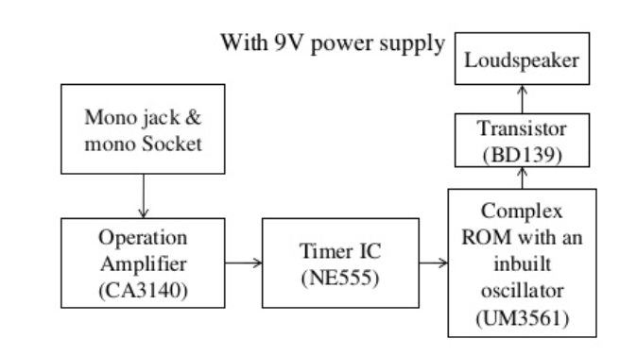

**CHAPTER 05**

**RESULT AND DISCUSSION**

Here, are some of the outputs obtained in the project:

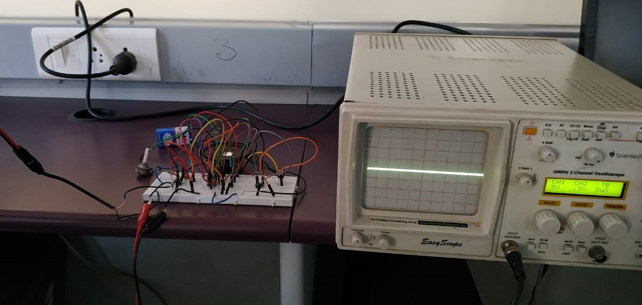

When 9V supply is applied in the above image we can see that for the IC CA3140 when the monoplug is connected the line is at origin. Now, we remove the monoplug which was attached before and observe the output which is shown below.

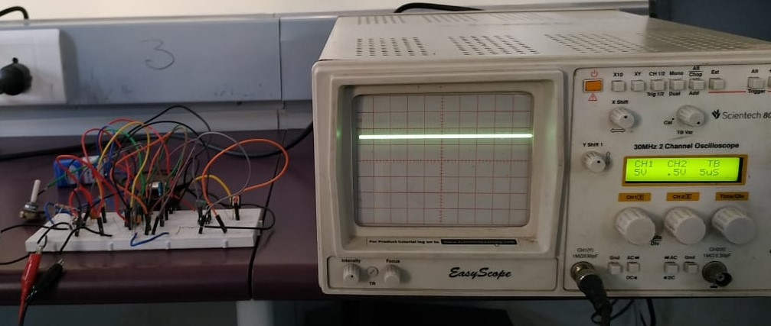

When 9V is supplied to the circuit, and when the monoplug is removed the line rises a bit say by 10V. So, from this we can conclude that the IC CA3140 is in working condition. So, now the voltage goes to the next IC i.e. 555Timer and then it passes to the next IC i.e. UM 3561 and then it goes to the transistor where the signal gets amplified and produces an alarm. Now the circuit is ready for use.

**CHAPTER 06**

**CONCLUSION AND FUTURE SCOPE**

It can be kept in a bag or suitcase while travelling which saves our life from theft by intruders. When the bag is snatched the monoplug gets detached and the alarm gets activated immediately. Here, is an alert against the theft of very simple and very useful project, used in the bag or suitcase to prevent theft. The heart of this entire burglar alarm circuit is the CA3140 IC operational amplifier, configured as a comparator. The two inverting and non-inverting inputs are respectively assigned to pins 3 and 2 of the operational amplifier and the output is obtained from pin 6. IC2 is used as a monostable multivibrator. The timing component used in this project is resistor R5, VR and capacitor C2 with the value indicated in the circuit diagram. For the audio section, IC3 is used as an alarm generator with integrated oscillator. Finally, the output is obtained from pin 3 of IC3 and is amplified by the transistor T1 to obtain the desired level and finally the alarm is generated by the speaker. Hence, we can conclude from this that this circuit will be very useful to prevent theft from burglars while travelling long distances. It can be kept in handbags especially in case women to save their lives from snatching and to prevent theft from burglars. To this device we can also add a GPS enabled system so, that when a bag or suitcase gets lost, we can easily track it from this GPS system using an interface installed in our mobiles. So, mainly it can be used as a security while travelling.

**REFERENCES**

* Elder J, “Method and apparatus for detecting at a distance the status and identity of objects”, 1973.
* Heck L.D. and A.L. Williams, “system and method for detecting unauthorized removal of goods”, 1975.
* Pokalsky, “Theft detection apparatus and target and method of making same” 1986.
* Fearon E.R., “Antitheft system” ,1985.
* Carter C. and S. Newfeld, “Alarm apparatus for facilitating the detection of an unauthorized removal of property”, 1974.
* Andreasen H.P. and W.B. Spargur, “Anti-theft detection system”, 1999.
* Hossain. S, “Anti bag alarm”, 2009.
* Masum. A. I, “design and construction of anti-snatching alarm”, 1993.

**APPENDIX**

IC CA3140: -

**[](https://www.electroschematics.com/wp-content/uploads/2010/07/CA3140-Pins.png?resize=200%2C102)**

DATASHEET: -

|  |  |  |
| --- | --- | --- |
| Parameter | Symbol | Typical values |
| Input resistance | Ri | 1.5 |
| Input capacitance | Ci | 4 |
| Output resistance | Ro | 60 |
| Gain-bandwidth | fT | 4.5 |
| Slew rate | SR | 9 |
| Input offset voltage | Vio | 5 |
| Input offset current | Iio | 0.5 |
| Input current | I1 | 10 |



IC NE555: -



DATASHEET: -

|  |  |  |
| --- | --- | --- |
| Parameter | Symbol | Typical values |
| Supply voltage | Vcc | 16 |
| Power dissipation | Pd | 600 |
| Temperature range | Tamb | 0 to 70 |
| Storage temperature change | Tstg | -65 to +150 |
| Lead soldering temperature | Tsold | 230 |



IC UM3561: -



DATASHEET: -

|  |  |  |
| --- | --- | --- |
| Parameter | Symbol | Typical values |
| Operating voltage | Vdd | 3.6V |
| Operating current | Idd | 150uA |
| “H” input voltage | VIH | Vdd |
| “L” input voltage | VIL | Vss+0.2 |
| Output current | Io | 3Ma |

